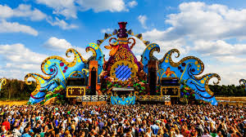

**When you think of Allgäu/Bavarian-Swabia, there is one thing that immediately comes to mind: Neuschwanstein Castle. The royal castle, which was built by Ludwig II, still ranks at the top of the list of the most popular German tourist destinations to this day. Each year, 1.2 million people travel from across the world to Füssen to see the fairytale castle. The towns of Augsburg, Kempten, Memmingen, Wangen and Nördlingen are usually little more than an afterthought…**